Online Food Ordering Management System

***Abstract:*** *Online food ordering management system is a software used to ease the customer’s life. Sometimes you don’t feel like cooking or doesn’t feel like to go to the restaurants, therefore we here propose an Online Food Ordering Management System which can help the customers to get food delivered immediately. This is mostly designed for a single restaurant having various food items at valuable food price. It gives effective way to order your food and almost within no time food will be delivered. Customer, he/she has login form with password in order to secure the information details and then they can select his/her favourite food items, place the order, also mention the quantity and finally can make the payment. When the order is placed, it gets stored in the database of the restaurants and then the staffs go through the orders and processes it efficiently.*

***Problem Statement:****To design an enhanced food delivery system and experience for customers such that they get a better experience right from the ordering stage to food delivery and the after service*

***Objectives:***

***The study has the following specific objectives:***

* *To develop a system that will surely satisfied the customer service.*

* *To design a system able to accommodate huge amount of orders at a time.*

* *To evaluate its performance and acceptability in terms of security, user-friendliness, accuracy and reliability.*

* *To improve the communication between the client and the server and minimize the time of ordering.*

***Scope of food ordering system:***

*In this article we the scope of the food ordering system. It is a computerized ordering system that adopts new technologies for supporting them in their best ways. The system obtains a notification after receiving the order, confirmation to the inventory system for products monitoring. The system will be holding all the Catabases of the customers that order through it.*

*There are various prominent things involved within it that attract both the customers and the food industries. Such as security structure, system back up, and system restore, system access, information about the order, and safe, secured, and reliable system. Companies need to keep their user information private to avoid any further complications. System Back up and system restore are related to storage processing, the files saved on a USB flash drive, cloud, or a hard drive.*

*System accessing will be in a simple Format, the administrator of the restaurant can edit, modify, add, and view the menu and reports through this easily. A food ordering system is software solution for users to take orders online easily and restore the customer's data. It is creating good communication between the customers and restaurants. The system is protecting the information from the risk of possible file loss and will have backup files, so that information will be safe.*

***Methodology:***

*The application starts by displaying the login or registration form. If the user is ordering for first time then, he/she has to first ‘Register’ and then they can start viewing the deals. Else, if it’s not their first time then they have to ‘Login’ with all the credentials such as filling his/her first name, last name, phone number, Email Id, address and password. Once he/she has successfully logged in, they will be able to see the ‘Home page’ with a dashboard of menus, orders and food cart. He/she has to choose their favourite dishes from the menu, then place their favourite dishes in the food cart, this food cart will help them to customize the orders like increasing the quantity, removing the food items etc. Once he/she is done customizing their orders, they can checkout and will be redirected to the final order page including their personal details, their orders, total amount to be paid with appropriate payment method. Lastly, they can just pay the amount by selecting the payment method of their choice and simply log-out.*

***Software Requirements :***

*Front-end:-*

* ***HTML*** *(Hypertext Markup Language) is the most basic building block of the Web. It defines the meaning and structure of web content. Each page contains a series of connections to other pages called hyperlinks. Every web page you see on the Internet is written using one version of HTML code or another.*
* ***CSS*** *(Cascading Style Sheets) is a simple mechanism for adding styles (e.g., fonts, colours, spacing) to Web documents. CSS defines how HTML elements are to be presented on screen, paper, or in other media. CSS saves a lot of work. It can control the layout of multiple web pages all at once.*

*Back-end:-*

* ***PHP*** *is a server-side scripting language. that is used to develop Static websites or Dynamic websites or Web applications. PHP stands for Hypertext Pre-processor, which earlier stood for Personal Home Pages. PHP scripts can only be interpreted on a server that has PHP installed.*
* *WAMP SERVER: WampServer refers to a software stack for the Microsoft Windows operating system, created by Romain Bourdon and consisting of the Apache web server, MySQL database and PHP programming language.*

*The database language used in our project:-*

***MySQL****: MySQL is a relational database management system based on SQL – Structured Query Language. The most common use for MySQL, however, is for the purpose of a web database. Standard SQL commands such as ADD, DROP, INSERT and UPDATE can be used in MYSQL****.***

***Proposed Architecture Diagram:***

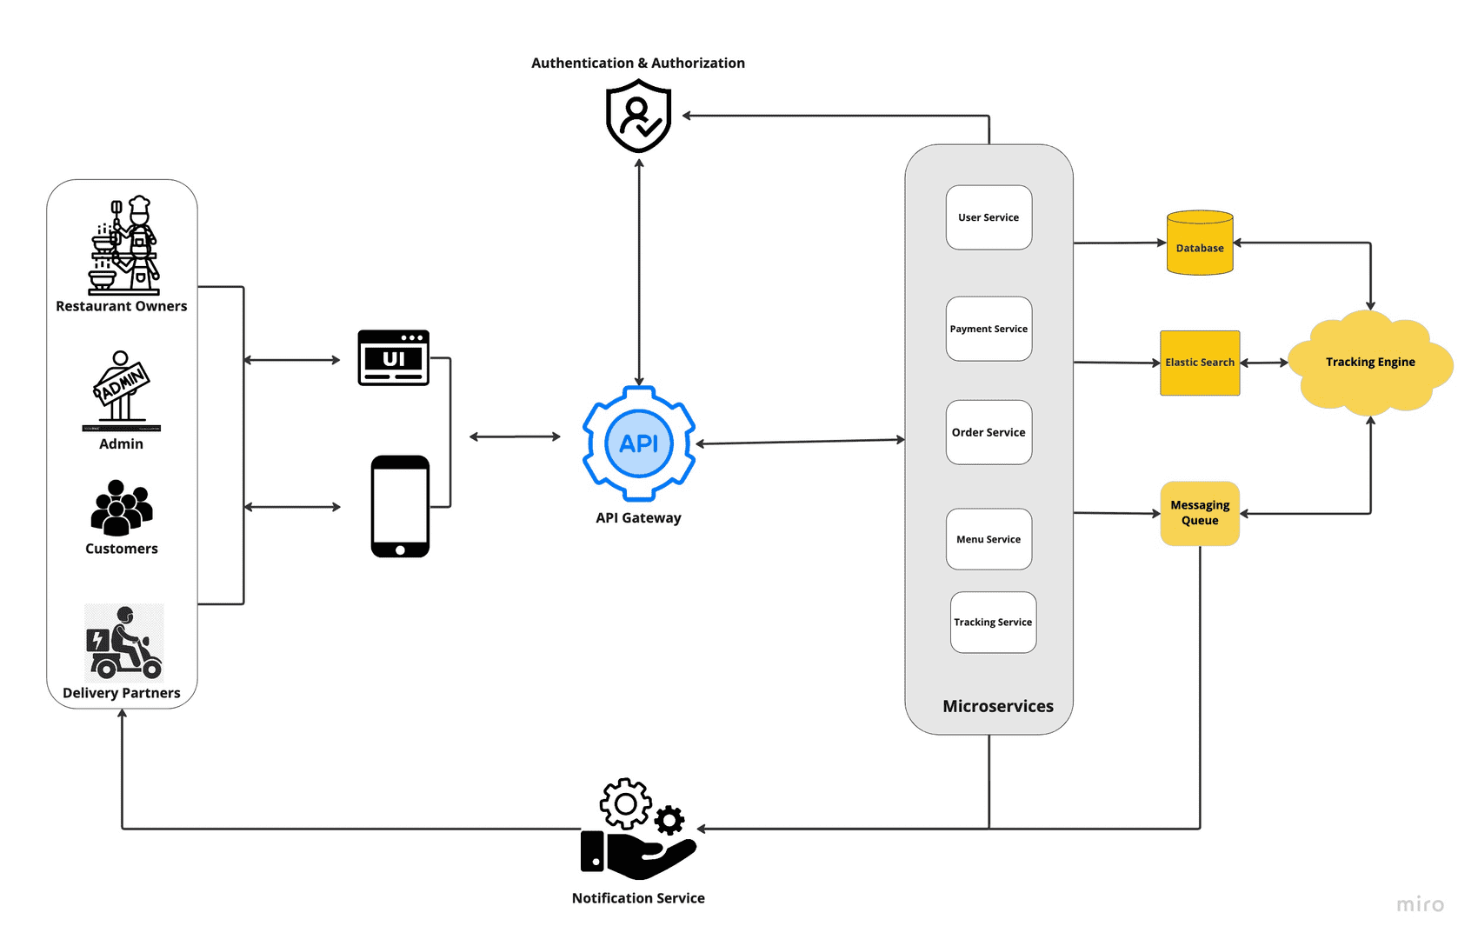

***Use-case Diagram:s***

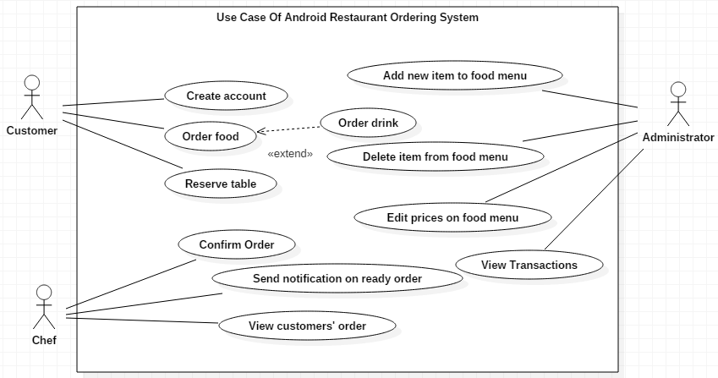

***ER model representation of online food ordering system:***

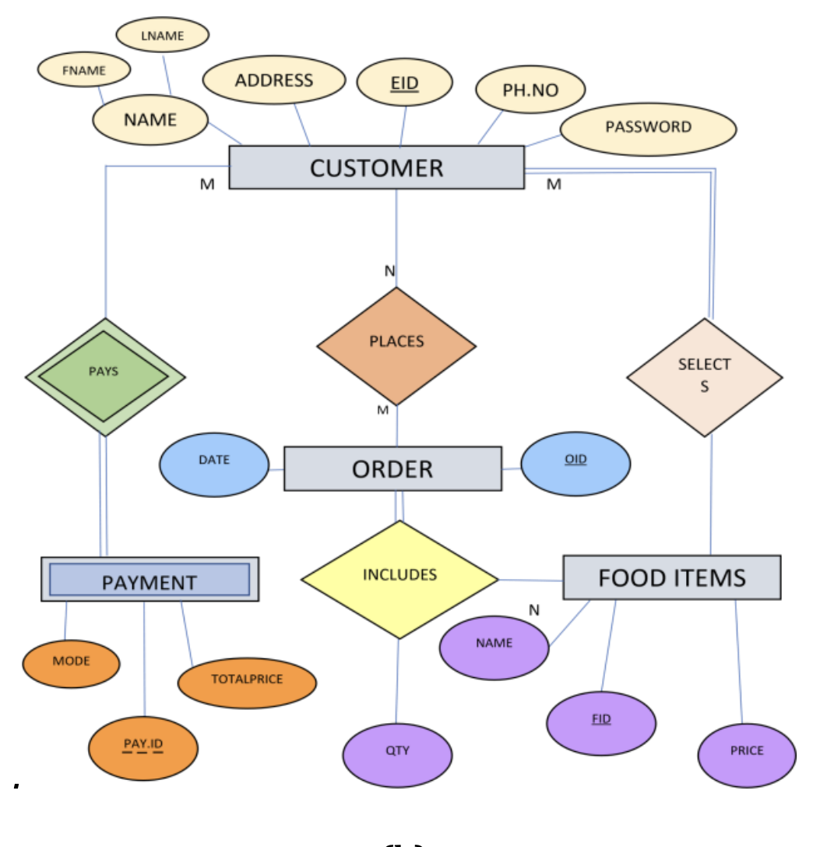

***Comments :***

***References:***

***(a)***[***https://www.irjet.net/archives/V7/i11/IRJET-V7I1167.pdf***](https://www.irjet.net/archives/V7/i11/IRJET-V7I1167.pdf)